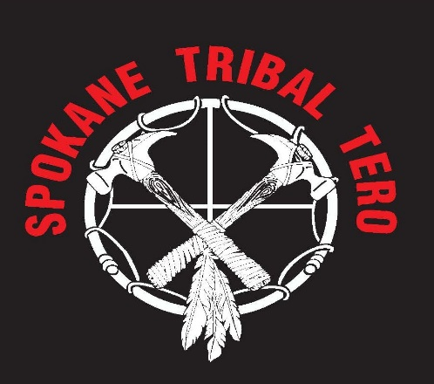

LOCAL COMPANIES LOCATED ON OR NEAR THE RESERVATION WITH INDIAN PREFERENCE QUALIFICATIONS
Spokane Tribal Owned Companies or Enterprises:
Moyer Construction – General Contractor/Supplier
Kay Moyer -(Management/Consulting
P.O. Box 263
Wellpinit, WA 99040
(509) 258 -7711
Moyerwellpinit@aol.com

Eagle River Construction – General Contractor
Richard Curtiss/Nic Vivitt – Superintendent
P.O. Box 141288
Spokane Valley, WA 99214
(509) 280-3547
(509) 991-4435

The Potty Barn – Sanitation Porta Pots
Clint Kieffer – Owner
6738 Kieffer Rd.
Davenport, WA 99122
(509) 724-3194
(509) 348 – 0239
thepottybarn@hotmail.com

Dardan Enterprises, Inc. – General Contractor/Commercial Construction
Daniel Stewart – Owner
23567 Hwy 53
Post Falls, ID 83854
Office (208) 773-8038
Cell (509) 280-6060
dan@dardaninc.com

T’shimakain Creek Laboratories - Water Testing/Drug Testing/Covid Testing
Spokane Tribal Enterprise
5503 E. Broadway Ave.
Spokane Valley, WA 99212
1-800-472-9915
(509) 928-3577

Womer and Associates Inc. – Architecture Engineering Planning
Rick Mathews – Owner
Old City Hall Bldg.
221 N. Wall St. Suite 600
Spokane, WA 99201
(509) 534-4884

Hest Collaborations, LLC - Garment Printing Custom Designs
Estabon Hayes – Owner
4920 Rural Ave.
Ferndale, WA 98248
(360) 742-4304
contactus@hestcollaborations.com
hestcollaborations.com
Other Indian Owned Companies

White Shield, Inc. – Land Surveying, Construction Surveying, Mapping,
Environmental Consulting
Stuart Fricke - Owner
320 N. 20th Avenue
Pasco, WA 99301
(509) 547-0100

Akana - Architecture and Engineering Services
Herbert Fricke – Owner
6400 SE Lake Road, Suite 270
Portland, OR 97222
(503) 652 – 9090

Apollo Sheet Metal, Inc. – Mechanical Construction HVAC Piping/Plumbing
Bruce Ratchford – Owner
1133 W. Columbia Drive
Kennewick, WA 99336
(509) 586-1104

Encompass Native Development Design Construct LLC – Professional Consulting Services, Feasibility Studies, Operations, Staffing Assessments
Joseph Vance – Owner
2510 E. 15th Suite 201
Tulsa, OK 74101
(502) 773-8750

Cates & Erb, Inc. – Heavy Construction and General Contractor
Robert Erb Jr.
P.O. Box 2027
Omak, WA 98841
(509) 826-4752

TAS Mechanical and Green Plumbing LLC
Harley Swan – Owner
P.O. Box 32
Wellpinit, WA 99040
(509) 879-4079
nwgreenplumber@gmail.com

Eldred & Associates – Land use planning, permitting projects with environmental impacts
Jennifer Eldred
209 Ferry St. Suite D
Sedro – Woolley, WA 98284
(360) 873-8156
jennifer@eldredassoc.com

Great Floors, LLC – Flooring Contractor
Don Chadderdon – Owner
524 E. Sherman Ave.
Coeur d’Alene, ID 83814
(208) 664-5405

Frye Mechanical, LLC – Plumbing and Pipefitting
James Frye – Owner
18821 E. Castillo
Otis Orchards, WA 99027
(509) 822-7374

Green Water Energy, LLC – Plumbing and HVAC
Erin Clemens – Owner
P.O. Box 1964
Clarkston, WA 99402
(509) 254 -5610
erin@greenh2oenergy.com

Scout Lake Construction, Inc. – General Contractor
Rodney Chumley – Owner
P.O. Box 1060
Selah, WA 98942
(509) 698 – 0752
rodc@scout-lake.com

WHH Nisqually Federal, LLC – General Construction, Construction Mgmt.
Charles Iyall – Chairman
John Kirk – General Manager
12820 Yelm Highway SE
Olympia, WA 985132
(253) 722-5928

Great Spaces, LLC – Office furnishings
5716 E. Sprague Ave.
Spokane Valley, WA 99212
(509) 747-2636

All Directions Cleaning Services
Angelica Roberts
33530 12st Way South #102
Federal Way, WA 98003
(253) 237-0537 – 1118
Angelica_Roberts@ymail.com

WENAHA GROUP, INC.
505 S. 336th St, Suite 630
Federal Way, WA 98003
(253) 433-3995
Robert Quaempts, Owner

